**Skewness measures how asymmetric (lopsided) a distribution is.**

* **Types of skewness**

1. **If data is perfectly symmetrical (like a normal distribution), skewness = 0.**
2. **Positive Skew (Right Skewed)**

* Tail is longer on the **right side**.
* Most data points are **towards the left (lower values)**.
* **Mean > Median > Mode**

Example: Income distribution in a country (most people earn less; a few earn extremely high).

1. **Negative Skew (Left Skewed)**

* Tail is longer on the **left side**.
* Most data points are **towards the right (higher values)**.
* **Mean < Median < Mode**

Example: Age of retirement (most people retire at ~60+, very few at much younger ages).

Example table:

| **Student** | **Marks (Left Skewed)** | **Marks (Symmetrical)** | **Marks (Right Skewed)** |
| --- | --- | --- | --- |
| A | 90 | 40 | 10 |
| B | 85 | 45 | 20 |
| C | 80 | 50 | 30 |
| D | 75 | 55 | 35 |
| E | 70 | 60 | 40 |
| F | 65 | 65 | 45 |
| G | 60 | 70 | 50 |
| H | 55 | 75 | 55 |
| I | 50 | 80 | 60 |
| J | 45 | 85 | 65 |

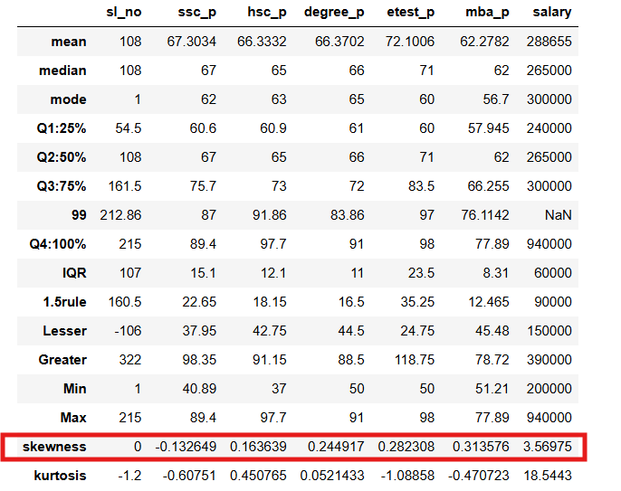

Sl.no is perfectly symmetrical ,normal distribution,skewness=0

SSC_P= -0.1326 ,

skewness is negative 🡪 Left skewed

Most of the ssc_p marks are high

Hsc_p,degree_p,etest_p,mba_p salary are positive means right skewed

The datapoints of these coloumns are lower

**Kurtosis**

**Kurtosis measures the “tailedness” or peakness of a distribution.**

In simple words: **How heavy or light are the tails compared to a normal distribution**

### ****Types of Kurtosis****

#### ****1. Mesokurtic (Normal Kurtosis)****

* **Kurtosis = 3**
* Shape similar to **normal distribution**.
* Standard tails and peak.

#### ****2. Leptokurtic (High Kurtosis)****

* **Kurtosis > 3**
* Distribution has:
  + **Sharper peak**
  + **Fatter/heavier tails**

Example: Data with frequent extreme outliers (e.g. stock market daily returns).

#### ****3. Platykurtic (Low Kurtosis)****

* **Kurtosis < 3**
* Distribution has:
  + **Flatter peak**
  + **Thinner tails**

Example: Data spread out evenly with fewer outliers.

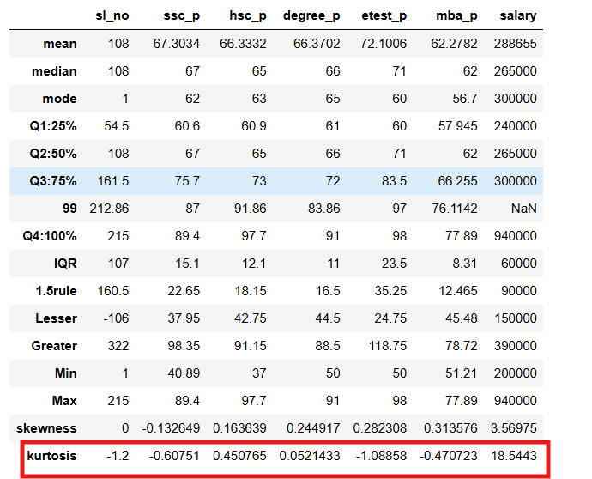

Sl.no ,ssc_p,hsc_p,degree_p,mba_p,etest_p are <3 means platykurtic(Values are spread flatter)

Salary is Laptokurtic(Values are fatter in tails and sharper peak)